CHAPTER FOUR

SYSTEM IMPLEMENTATION

4.1 Chapter Overview
This chapter presents the analysis and interpretation of data collected from 2,576 respondents sampled from the Nigerian telecommunications sector, focusing on MTN and Airtel customers. The analysis aims to explore key factors that influence customer churn and compare churn rates between these two dominant service providers.
The data were obtained electronically through structured questionnaires administered via Google Forms. After data cleaning (missing values removal, etc.), the sample size was refined to 1, 383 respondents, as other entries were excluded due to incomplete or inconsistent responses. The remaining data provides a robust foundation for analyzing key demographic information, customer satisfaction levels, subscription patterns, and usage behaviors.
By examining these responses, the study seeks to uncover significant patterns contributing to customer churn and assess how these factors align with the research objectives. This chapter also offers a detailed breakdown of the findings, including descriptive statistics and the relationship between various factors such as age, gender, subscription type, and monthly spending with customer churn. The goal is to generate insights that can help reduce churn rates and improve customer retention in Nigeria's highly competitive telecommunications industry.
Tables 4.1.1 - 4.1.10 captures the demographic profiles of the customers indicating the various frequency and percentage distribution of the considered profiles of the respondents. A detailed analysis is presented in preceding sections.

Table 4.1.1 Age Distribution of Respondents
Age Group (Years) | Frequency | Percentage (%)
18 – 24 | 300 | 21.7%
25 – 34 | 420 | 30.4%
35 – 44 | 340 | 24.6%
45 – 64 | 260 | 18.8%
65+ | 62 | 4.5%
Total | 1,383 | 100%

Analysis:
The age distribution of the 1,383 respondents reveals a clear trend in the demographic composition of the sample. The majority of respondents fall within the 25 - 34 age group, accounting for 30.4% of the total sample. This suggests that the telecom sector, particularly among MTN and Airtel subscribers, is largely driven by young adults in this age range, likely reflecting a high level of digital engagement and mobile usage within this group.
The second-largest group is the 35 - 44 age category, representing 24.6% of the respondents. This segment likely includes working professionals and middle-aged individuals who rely heavily on mobile connectivity for both personal and professional purposes.
Interestingly, the 18 - 24 age group makes up 21.7%, indicating that younger users are also a significant part of the customer base. This suggests a growing adoption of mobile services among younger demographics, who are likely frequent users of data-intensive applications such as social media and streaming platforms.
The 45 - 64 age group contributes 18.8% to the total respondents, highlighting that older adult, though less prevalent, are still active subscribers. Finally, the 65+ age group, with 4.5%, represents the smallest portion of the sample, which could indicate a lower level of mobile engagement among seniors, possibly due to generational differences in technology adoption.

Table 4.1.2 Gender, Subscription Type, Occupation and Educational Level Distribution
Demographic Variable | Categories | Frequency | Percentage (%)
Gender | Male | 700 | 50.6%
 | Female | 683 | 49.4%
TOTAL |  | 1,383 | 100%
Subscription Type | Prepaid | 1,099 | 79.5%
 | Postpaid | 284 | 20.5%
TOTAL |  | 1,383 | 100%
Occupation | Student | 420 | 30.4%
 | Employed | 459 | 33.2%
 | Self-employed | 300 | 21.7%
 | Retired | 83 | 6.0%
 | Unemployed | 100 | 7.2%
 | Other | 19 | 1.4%
TOTAL |  | 1,383 | 100%
Education Level | High School | 360 | 26.0%
 | Undergraduate | 660 | 47.7%
 | Postgraduate | 300 | 21.7%
 | Other | 62 | 4.5%
TOTAL |  | 1,383 | 100%

Analysis:
The demographic distribution across Gender, Subscription Type, Occupation, and Education Level provides a comprehensive understanding of the respondents' profiles:
- Gender: The gender distribution is almost evenly split, with 50.6% male and 49.4% female respondents. This balance ensures a fairly equal representation in terms of gender, which is crucial for evaluating any gender-based differences in churn patterns.
- Subscription Type: The overwhelming majority of respondents (79.5%) use Prepaid services, while only 20.5% are Postpaid subscribers. This is consistent with the Nigerian telecom market, where prepaid services dominate due to their flexibility and affordability. The postpaid customers, being fewer, might represent higher-income users or corporate clients, a factor that could influence churn differently across these segments.
- Occupation: The largest occupation category is Employed individuals (33.2%), followed by Students (30.4%). This suggests that a significant portion of the respondents are either young professionals or students, both of which are active mobile users. Self-employed individuals make up 21.7%, which might reflect entrepreneurial activities, while smaller percentages are observed for Retired (6.0%) and Unemployed (7.2%) respondents.
- Education Level: Nearly half of the respondents (47.7%) have an Undergraduate level of education, indicating a relatively educated user base. Postgraduate degree holders make up 21.7%, while 26.0% have completed only High School. This range of education levels provides a broad spectrum for analysis, as education may correlate with mobile service preferences and satisfaction.

Table 4.1.3 Service Usage Distribution of Respondents
Service Usage Variable | Categories | Frequency | Percentage (%)
Average Monthly Spending (₦) | ₦1,000 - ₦5,000 | 839 | 60.7%
 | ₦5,001 - ₦10,000 | 360 | 26.0%
 | ₦10,001 - ₦20,000 | 140 | 10.1%
 | ₦20,001+ | 44 | 3.2%
TOTAL |  | 1,383 | 100%
Contract Length (Months) | 1 - 12 months | 1,000 | 72.3%
 | 13 - 24 months | 241 | 17.4%
 | 25 - 36 months | 102 | 7.4%
 | 37+ months | 40 | 2.9%
TOTAL |  | 1,383 | 100%

Analysis:
- Average Monthly Spending: The majority of respondents (60.7%) spend between ₦1,000 - ₦5,000 monthly, highlighting that most users fall within a lower spending range, typical of prepaid customers. Only a small fraction (3.2%) spend over ₦20,001, representing a premium user base.
- Contract Length: Most respondents (72.3%) have had contracts or subscriptions for 1 - 12 months, which aligns with the high churn rates typically seen in short-term engagements. Only 2.9% have been subscribed for over 37 months, suggesting a limited long-term customer base.

Table 4.1.4 Monthly Call Duration, Data Usage and Communication Method
Service Usage Variable | Categories | Frequency | Percentage (%)
Monthly Call Duration | 0 - 200 minutes | 701 | 50.6%
 | 201 - 500 minutes | 420 | 30.4%
 | 501 - 1,000 minutes | 189 | 13.7%
 | 1,001+ minutes | 73 | 5.3%
TOTAL |  | 1,383 | 100%
Monthly Data Usage | 0 - 5 GB | 560 | 40.5%
 | 6 - 15 GB | 500 | 36.2%
 | 16 - 30 GB | 250 | 18.1%
 | 31+ GB | 73 | 5.3%
TOTAL |  | 1,383 | 100%
Primary Communication Method | Voice Calls | 640 | 46.3%
 | Text Messaging | 160 | 11.6%
 | Internet/Data | 524 | 37.8%
 | Other | 59 | 4.3%
TOTAL |  | 1,383 | 100%

Analysis:
- Monthly Call Duration: Over 50.6% of respondents use 0 - 200 minutes monthly, indicating relatively low call activity. Only 5.3% report heavy call usage exceeding 1,001 minutes, representing high-call users.
- Monthly Data Usage: Most respondents (40.5%) use between 0 - 5 GB of data monthly, reflecting light internet usage. However, 36.2% fall into the 6 - 15 GB range, indicative of more moderate usage patterns, and only 5.3% consume over 31 GB monthly.
- Primary Communication Method: A substantial portion of respondents (46.3%) still prefer voice calls, but 37.8% are primarily reliant on internet/data for communication, showcasing the growing importance of mobile data in Nigeria’s telecommunications sector.

Table 4.1.5 Distribution by Customer Experience
Customer Experience Variable | Categories | Frequency | Percentage (%)
Number of Complaints Filed in the Last 6 Months | 0 | 600 | 43.4%
 | 1 - 2 complaints | 440 | 31.8%
 | 3 - 5 complaints | 200 | 14.5%
 | 6 - 10 complaints | 100 | 7.2%
 | 11+ complaints | 45 | 3.1%
TOTAL |  | 1,383 | 100%

Analysis:
- 0 Complaints: A significant 43.4% of respondents have not filed any complaints in the last 6 months, suggesting a degree of satisfaction or lack of engagement with customer service.
- 1 - 2 Complaints: 31.8% of customers have filed 1 to 2 complaints, indicating moderate dissatisfaction or issues that have been partially addressed.
- 3 - 5 Complaints: 14.5% of respondents have reported filing 3 to 5 complaints, which may reflect more persistent service issues or higher dissatisfaction levels.
- 6 - 10 Complaints: A smaller segment, 7.2%, have filed between 6 and 10 complaints, pointing to frequent issues and potentially significant service quality concerns.
- 11+ Complaints: Only 3.1% of customers have filed more than 11 complaints, representing the most dissatisfied customers or those experiencing severe and recurring issues.
This distribution highlights the varying levels of customer satisfaction and potential service quality problems. A substantial proportion of customers are either content or minimally dissatisfied, while a smaller yet significant percentage are highly dissatisfied, which could be a critical focus for improving customer service.

Table 4.1.6 Nature of Complaints by Customers
Nature of Complaints | Frequency | Percentage (%)
Service Quality | 499 | 36.1%
Billing Issues | 360 | 26.0%
Network Coverage | 241 | 17.4%
Customer Service | 160 | 11.6%
Technical Issues | 80 | 5.8%
Other | 43 | 3.1%
TOTAL | 1,383 | 100%

Analysis:
- Service Quality: The most common complaint, 36.1% of respondents report issues related to service quality. This indicates that improving the overall service quality should be a priority for reducing churn and enhancing customer satisfaction.
- Billing Issues: 26.0% of complaints are about billing issues, highlighting a need for better transparency and accuracy in billing practices.
- Network Coverage: 17.4% of respondents cite network coverage as a problem. This suggests that expanding network infrastructure or improving signal strength could help retain customers.
- Customer Service: 11.6% of complaints are related to customer service, indicating that customer support interactions may need improvement.
- Technical Issues: 5.8% report technical issues, which might suggest that while less common, these problems still affect a significant portion of users and should be addressed.
- Other: 3.1% of complaints fall into the "Other" category, reflecting diverse issues not covered by the main categories.
This distribution provides insights into the specific areas where customers face problems and helps prioritize areas for improvement to enhance overall customer satisfaction and reduce churn.

Table 4.1.7 Overall Satisfaction with Service
Overall Satisfaction with Service | Frequency | Percentage (%)
Very Dissatisfied | 100 | 7.2%
Dissatisfied | 201 | 14.5%
Neutral | 300 | 21.7%
Satisfied | 498 | 36.1%
Very Satisfied | 284 | 20.5%
TOTAL | 1,383 | 100%

Analysis:
- Very Dissatisfied: 7.2% of respondents are very dissatisfied with the service. This indicates a segment of customers who are extremely unhappy, which could be critical to address to prevent further churn.
- Dissatisfied: 14.5% express dissatisfaction. Combined with the very dissatisfied group, this represents 21.7% of customers who are not pleased with their service, signaling a need for substantial improvements.
- Neutral: 21.7% are neutral, suggesting these customers neither strongly like nor dislike the service. This group might be more susceptible to switching if competitors offer better services.
- Satisfied: 36.1% are satisfied, showing that a significant portion of customers have a positive view of their service, which is promising for customer retention.
- Very Satisfied: 20.5% are very satisfied, reflecting a strong segment of loyal customers who are likely to remain with the provider and may even advocate for the service.

Table 4.1.8 Likelihood of Switching Providers in the Next 6 Months
Likelihood of Switching Providers in the Next 6 Months | Frequency | Percentage (%)
Very Unlikely | 240 | 17.3%
Unlikely | 300 | 21.7%
Neutral | 240 | 17.3%
Likely | 361 | 26.0%
Very Likely | 242 | 17.5%
TOTAL | 1,383 | 100%

Analysis:
- Very Unlikely: 17.3% of respondents feel very unlikely to switch providers, indicating a stable segment of customers who are satisfied or have strong brand loyalty.
- Unlikely: 21.7% are unlikely to switch, further supporting the notion that a substantial portion of customers are relatively stable, though not as committed as the very unlikely group.
- Neutral: 17.3% are neutral regarding their likelihood of switching. This indicates a group that may be open to change depending on future experiences or promotions.
- Likely: 26.0% are likely to switch providers, highlighting a significant portion of the customer base that could be at risk of churn. This group could be influenced by competitive offers or dissatisfaction with current services.
- Very Likely: 17.5% are very likely to switch, representing a critical group for churn prevention strategies. Addressing their concerns or offering incentives could be essential to reducing potential loss.

Table 4.1.9 Factors Influencing Likelihood to Switch Providers
Factors Influencing Likelihood to Switch Providers | Frequency | Percentage (%)
Service Quality | 899 | 65.0%
Cost | 1037 | 75.0%
Offers and Promotions | 759 | 54.9%
Customer Service | 798 | 57.7%
Network Coverage | 660 | 47.7%
Ease of Switching | 420 | 30.4%
Other | 40 | 2.9%

In this type of multi-response question, respondents can indicate more than one factor, so the totals across factors can exceed the overall number of respondents.
Analysis:
- Service Quality: 65.0% of respondents indicated that service quality influences their likelihood to switch providers. This suggests that a significant number of customers prioritize high-quality service, and improvements in this area could reduce churn.
- Cost: 75.0% of respondents are influenced by cost. This is the highest factor influencing customer decisions, indicating that pricing strategies and competitive offers are crucial for retaining customers.
- Offers and Promotions: 54.9% of respondents consider offers and promotions a key factor. Providing attractive deals and incentives can help in retaining customers and attracting those considering switching.
- Customer Service: 57.7% of respondents are influenced by customer service. This underscores the importance of responsive and effective customer support in reducing churn.
- Network Coverage: 47.7% view network coverage as a factor. Ensuring comprehensive coverage and minimizing connectivity issues can help retain customers.
- Ease of Switching: 30.4% of respondents find the ease of switching important. Making the switching process simple and hassle-free can either encourage customers to move or, if managed well, reduce the likelihood of them leaving.
- Other: 2.9% of respondents selected other factors not listed. This indicates a small segment of unique concerns that may require further investigation to fully understand their impact.

Table 4.1.10 Additional Insights for Switching Providers
Primary Reasons for Considering Switching Providers | Frequency | Percentage (%)
Poor Service Quality | 958 | 69.3%
High Costs | 1019 | 73.7%
Better Offers from Competitors | 840 | 60.8%
Customer Service Issues | 780 | 56.4%
Network Coverage Issues | 639 | 46.2%
Other | 59 | 4.3%

In a multi-response scenario, respondents can select more than one reason. As a result, the sum of these frequencies (958 + 1,019 + 840 + 780 + 639 + 59 = 4,295) exceeds 1,383. Each frequency represents the number (and estimated proportion) of respondents indicating that specific reason
Analysis:
- Poor Service Quality: 69.3% of respondents cited poor service quality as a primary reason for considering switching. This indicates that addressing quality issues is critical to retaining customers.
- High Costs: 73.7% of respondents are considering switching due to high costs. This reinforces the need for competitive pricing and cost-effective plans to improve customer retention.
- Better Offers from Competitors: 60.8% are enticed by better offers from competitors. This highlights the importance of regular evaluations of competitors' offerings and ensuring that your own plans remain attractive.
- Customer Service Issues: 56.4% of respondents indicated customer service issues as a reason for switching. Enhancing customer service and resolving complaints efficiently can help in retaining customers.
- Network Coverage Issues: 46.2% reported network coverage issues as a factor. Improving network infrastructure to provide better coverage can reduce the likelihood of customers switching.
- Other: 4.3% provided other reasons not listed. This small percentage suggests that there may be niche concerns affecting a minor segment of the customer base.

4.2 Exploratory Data Analysis
The exploratory data analysis (EDA) of the telecommunications customers profile is presented in Table 4.2 with features and their data types. It indicates that 13 features were selected for prediction of customers churn behaviour. A total of 1,383 data points were split into two for training and testing the ML models in the ratio of 8:2.
The features include Age, Gender, Subscription Type, Occupation, Educational Level, Monthly Spending (NGN), Contract Length (Months), Monthly Data Usage (GB), Primary Communication Method, Customer Complaints and Churn as the output variable with two outcomes ’Yes’ or ‘No’. The EDA further categorize the data types as follows: float64(1), int64(4), object(8) with a memory usage of 702.4+ KB.

Table 4.2 Features Set and their Data Types
S/N | Features | Data Type
1 | Age | int64
2 | Gender | object
3 | Subscription Type | object
4 | Occupation | object
5 | Educational Level | object
6 | Monthly Spending (NGN) | int64
7 | Contract Length (months) | int64
8 | Monthly Call Usage (Minutes) | int64
9 | Monthly Data usage (GB) | float64
10 | Primary Communication Method | object
11 | Customer Complaints | object
12 | Telecom Provider | object
13 | Churn | object

The Subscription Type are Prepaid and Postpaid; Occupation are Student, Self-employed, Employed, Unemployed; Primary Communication Method includes Call, Text, and Data while Educational Level is Secondary or Tertiary. Furthermore, Figures 4.2.1 – 4.2.7 presents the Telecom customers distribution based on Gender, Subscription Type, Occupation, Educational Level, Complaints, Communication Method and Churn Tendency.
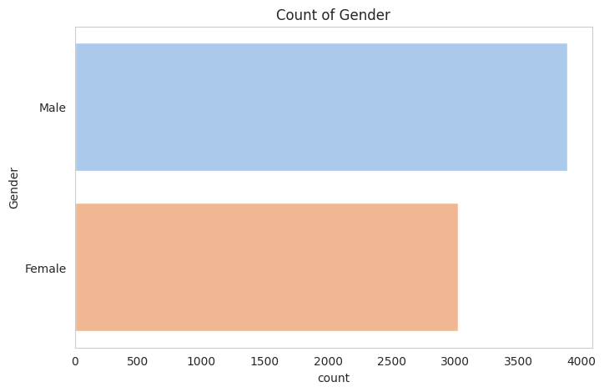

Figure 4.2.1 Customers Distribution based on Gender

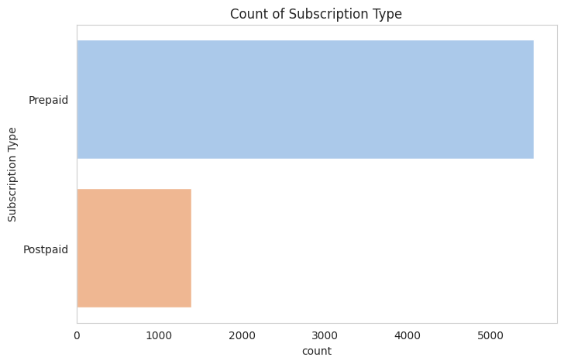

Figure 4.2.2 Customers Distribution based on Subscription Type

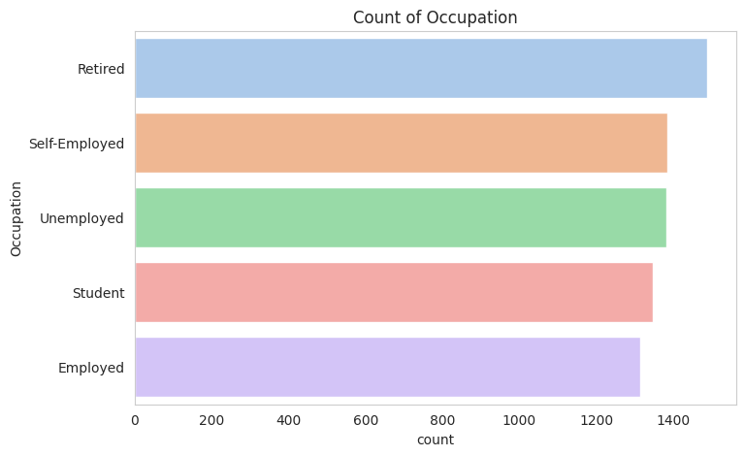

Figure 4.2.3 Customers Distribution based on Occupation

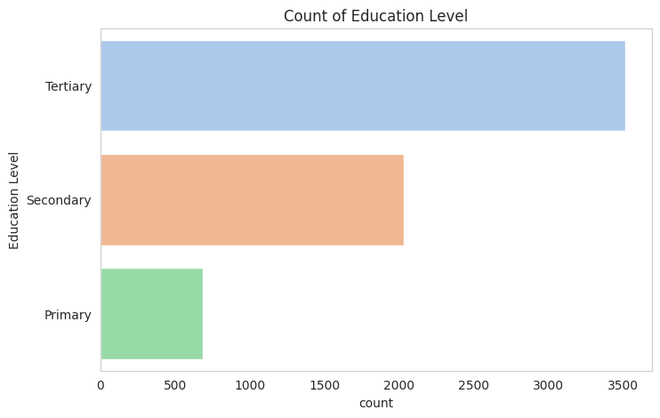

Figure 4.2.4 Customers Distribution based on Educational Level
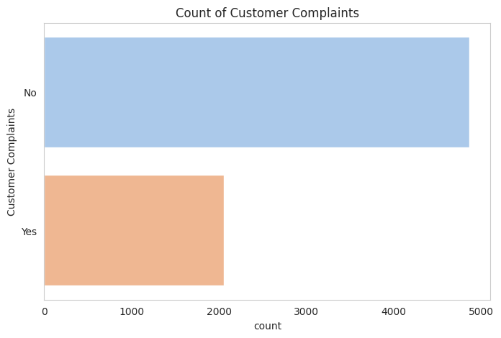

Figure 4.2.5 Customers Distribution based on Complaints

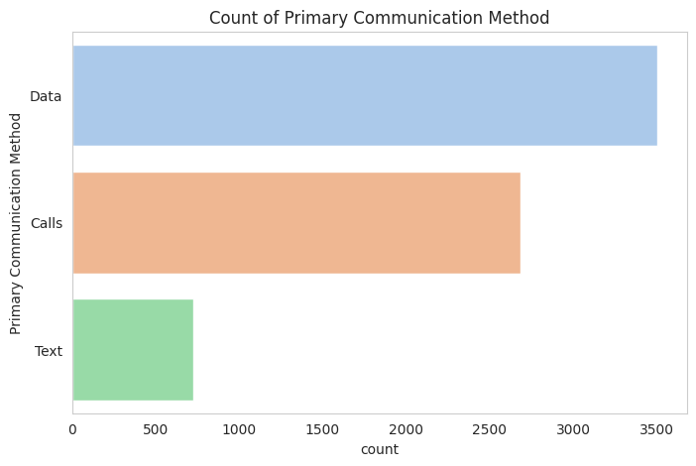

Figure 4.2.6 Customers Distribution based on Communication Method
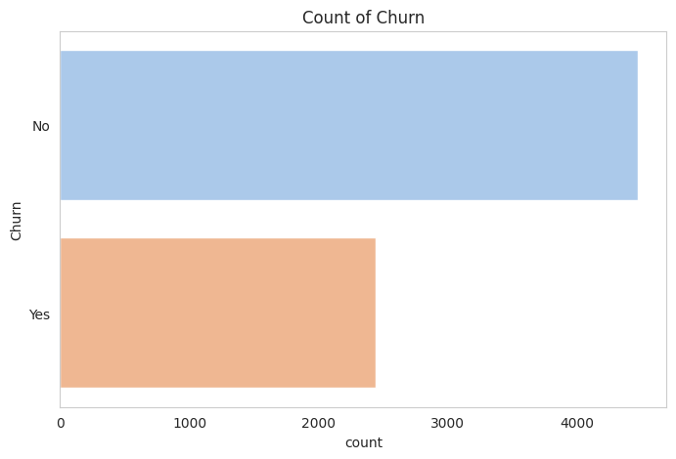

Figure 4.2.7 Customers Distribution based on Churning

The customers distribution being Age, Monthly Spending, Contract Length (Months), Monthly call Usage (Minutes), and Monthly Data Usage (GB) are presented in Figures 4.2.8 – 4.2.12.
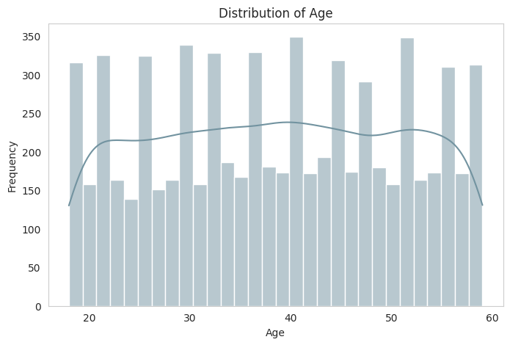

Figure 4.2.8 Customers Distribution based on Age

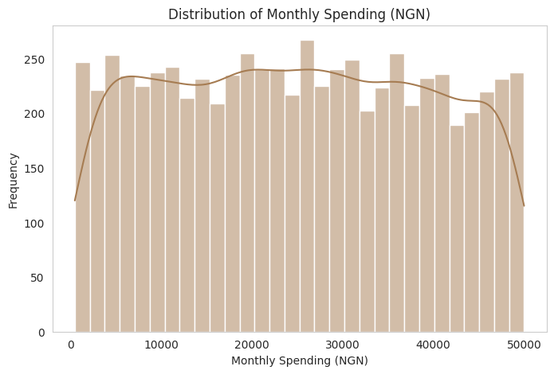

Figure 4.2.9 Customers Distribution based on Monthly Spending (NGN)

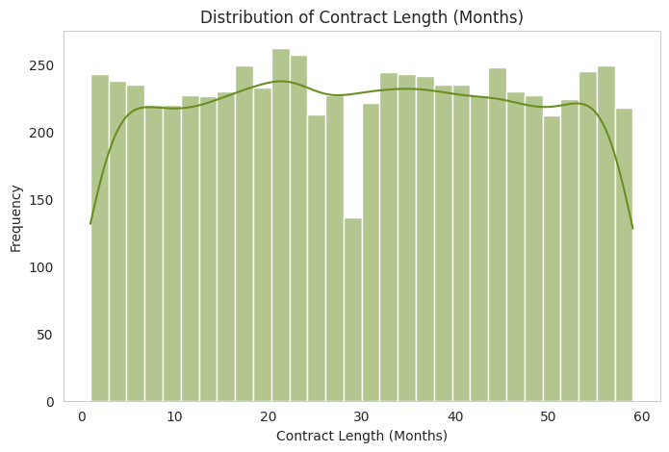

Figure 4.2.10 Customers Distribution based on Contract Length (Months)

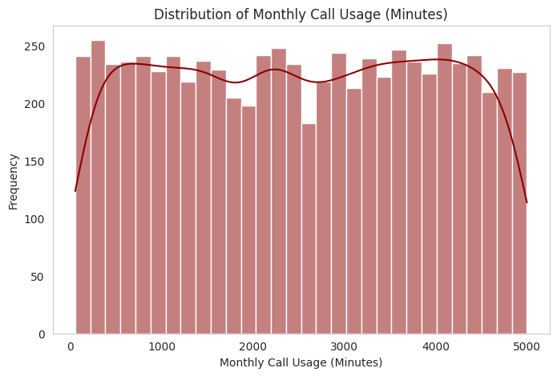

Figure 4.2.11 Customers Distribution based on Monthly Call Usage (Minutes)

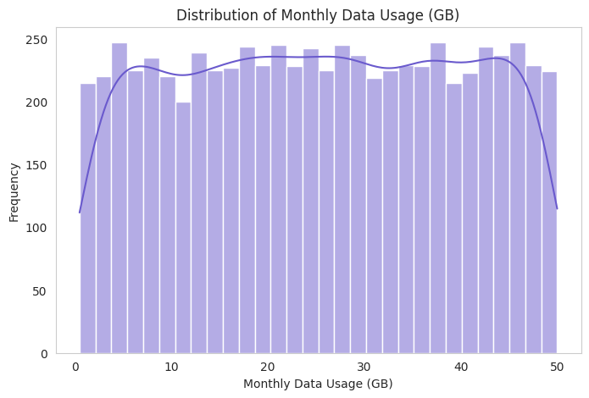

Figure 4.2.12 Customers Distribution based on Monthly Data Usage (GB)

The correlation heatmap in Figure 4.2.13 is used for feature engineering indicating important features for extraction and selection in the task of machine learning model building. Figure 4.2.13 shows the relationships between various numerical features in the telecommunications customer dataset, which can be used for churn prediction analysis. The following information can be extracted from this heatmap:
- Age has very little correlation with any other features, indicating that it does not significantly influence monthly spending, contract length, or usage behavior.
- Monthly Spending (NGN) is not strongly correlated with any of the other numerical features. This suggests that spending does not directly depend on contract length, call usage, or data usage, which might indicate different customer spending behaviors.
- Contract Length (Months) has a near-zero correlation with other features, meaning that customers' contract durations do not strongly relate to their spending or usage.
- Monthly Call Usage (Minutes) and Monthly Data Usage (GB) also show minimal correlation with other features. This means that customers' call and data usage patterns are independent of their age, contract length, and spending.

Implications for Churn Prediction
Since no strong correlations exist among these features, it suggests that churn may be influenced by other factors, such as customer service interactions, promotions, or external factors like competitor offerings.
Feature engineering was used to derive more meaningful variables that capture patterns related to churn. Result shows that non-numerical features, like contract type (prepaid vs. postpaid), customer complaints, or satisfaction scores, play a larger role in predicting churn.

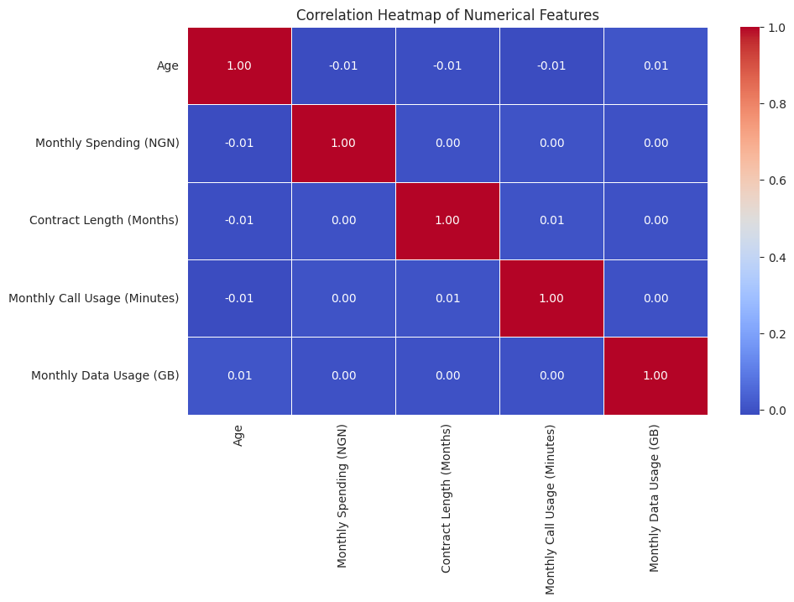

Figure 4.2.13 Correlation Heatmap

Figure 4.2.14 indicates the churn distribution of the customers while Figure 4.2.15 shows that churn rate by subscription type. Results indicate that more prepaid customers have the tendency to churn compared to postpaid customers.
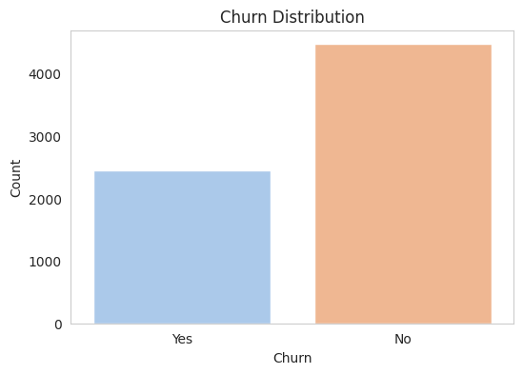

Figure 4.2.14 Churn Distribution of the Customers

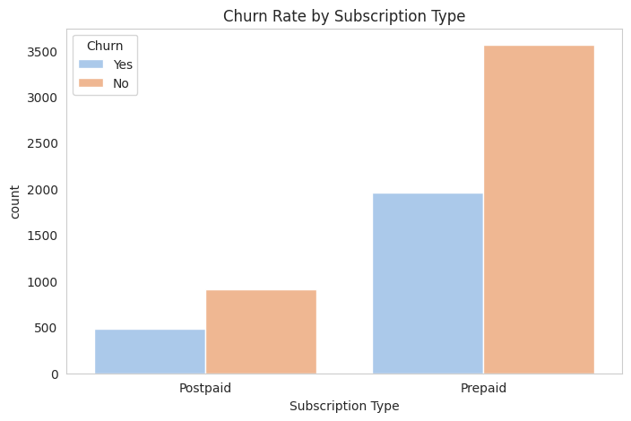

Figure 4.2.15 Churn Rate of the Customers based on Subscription Type

4.3 Machine Learning Model Performance on Churn Prediction
The Confusion matrices for each ML model is depicted in Figures 4.3.1 - 4.3.4 for the TP, TN, FP, and FN values with a total of 1,383 data points. The tabular results for diverse metrics including accuracy, recall, precision, and F1-score is presented in Tables 4.3.1 - 4.3.4
Results indicate that DT achieved the following performance in predicting customer churn: accuracy (0.54), precision (0.55), recall (0.54) and F1-score (0.55). On the other hand, RF model achieved the following performance: accuracy (0.64), precision (0.55), recall (0.64) and F1-score (0.54). Similarly, XGBoost model achieved the following performance: accuracy (0.61), precision (0.57), recall (0.61) and f1-score (0.58) while SVM achieved the following performance: accuracy (0.65), precision (0.43), recall (0.65) and F1-score (0.52).
Based on the dataset used, results indicate that SVM outperformed the ML models with highest accuracy of 65%, followed by RF (64%), XGBoost (61%) while DT had the least accuracy value of (54%). On the other hand, DT and RF had equal precision performance (55%), XGBoost had the highest precision (57%) while SVM had the least precision (43%). In terms of recall, SVM achieved the highest performance (65%), followed by RF (64%), XGBoost (61%) while DT had the least recall value (54%).
It can be deduced from the comparative performance plot of the ML models in Figure 4.3.5 that, based on accuracy and recall, the best model for predicting customer churn behaviour is SVM followed by RF. It therefore indicates that SVM is a powerful classification algorithm with capability to find the optimal hyperplane separating different classes in the feature space. Also, RF as an ensembled method proved its ability to combine multiple decision trees to improve predictive accuracy and reduce overfitting.

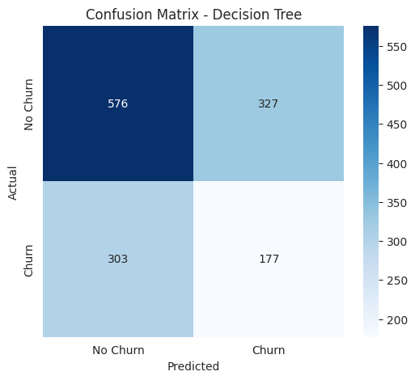

Figure 4.3.1 Confusion Matrix for DT

Table 4.3.1 Performance Evaluation Report for DT Model
precision recall f1-score support

0 0.66 0.64 0.65 903
1 0.35 0.37 0.36 480

accuracy 0.54 1383
macro avg 0.50 0.50 0.50 1383
weighted avg 0.55 0.54 0.55 1383

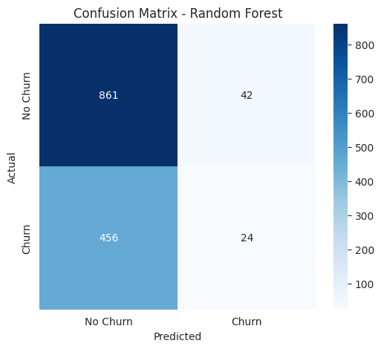

Figure 4.3.2 Confusion Matrix for RF

Table 4.3.2 Performance Evaluation Report for RF Model
precision recall f1-score support

0 0.65 0.95 0.78 903
1 0.36 0.05 0.09 480

accuracy 0.64 1383
macro avg 0.51 0.50 0.43 1383
weighted avg 0.55 0.64 0.54 1383

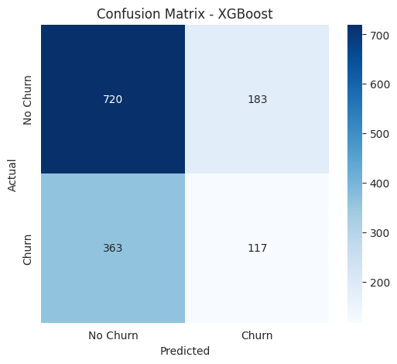

Figure 4.3.3 Confusion Matrix for XGBoost

Table 4.3.3 Performance Evaluation Report for XGBoost Model
precision recall f1-score support

0 0.66 0.80 0.73 903
1 0.39 0.24 0.30 480

accuracy 0.61 1383
macro avg 0.53 0.52 0.51 1383
weighted avg 0.57 0.61 0.58 1383

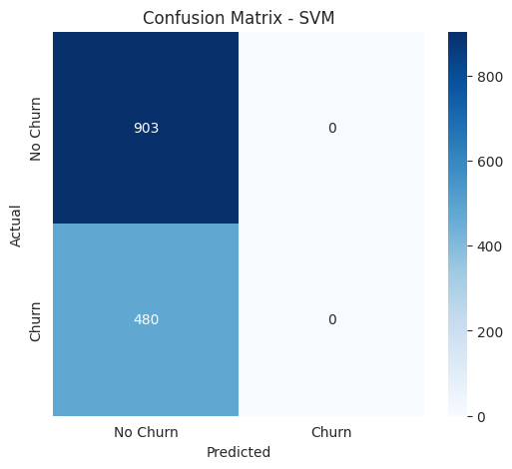

Figure 4.3.4 Confusion Matrix for SVM

Table 4.3.4 Performance Evaluation Report for SVM Model
precision recall f1-score support

0 0.65 1.00 0.79 903
1 0.00 0.00 0.00 480

accuracy 0.65 1383
macro avg 0.33 0.50 0.40 1383
weighted avg 0.43 0.65 0.52 1383

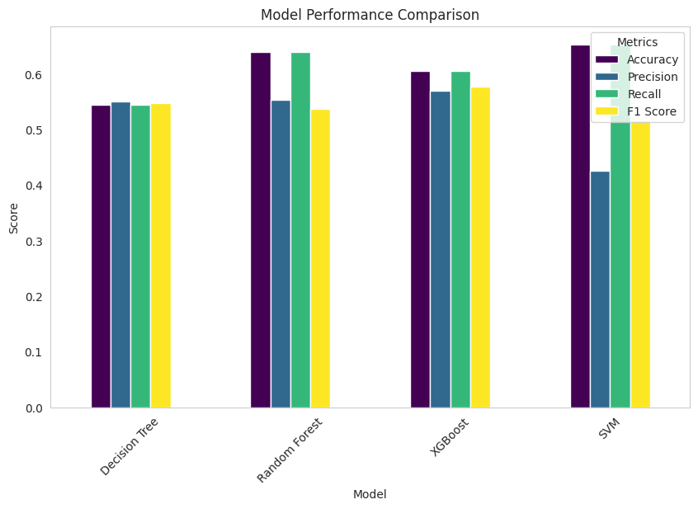

Figure 4.3.5 Comparative Performance of the ML Models

